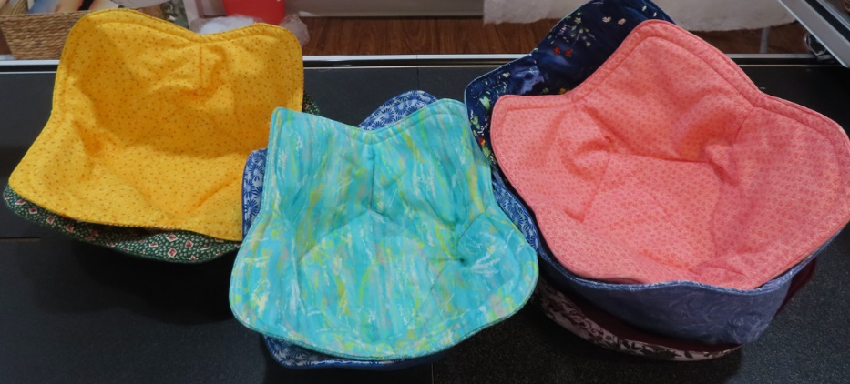
Make Bowls Cozy...
by making Bowl Cozies for the microwave. Use the little "ears" to pick up the bowl; then the cozy continues to keep it warm.

These bowl cozies are not only cute little gifts, but they are great for using up old fabric. They’re all the rage in the craft markets, and I'm on the band wagon because I'll have them for sale at the new non-profit Kelly Fitzpatrick Center for the Arts in Wetumpka, Al, opening June 29, 2023
-- Libby J. Christensen

SUPPLIES For a medium serving bowl, you need 2 fat quarters of coordinating fabrics and 32" by 16" of cotton batting, just under 1/2 yd. And thread. That's it! Here's how I make them:
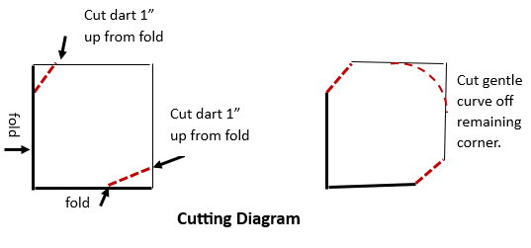
- Start by cutting 16" squares: 1 each from the two fat quarters, and I like 2 layers of cotton batting, so 2 squares of the batting. You'll be making 4 darts in the middle of the sides that make the sides stand up. (What I recommend is to make a pattern first out of paper or interfacing. All you need is an 8"square, which you can get out of regular computer or lined paper; this will represent one quarter of the 16" square folded into fourths.)

https://sewgocreate.com
© 2023 by Libby J. Christensen, Christensen Creations ALL RIGHTS RESERVED

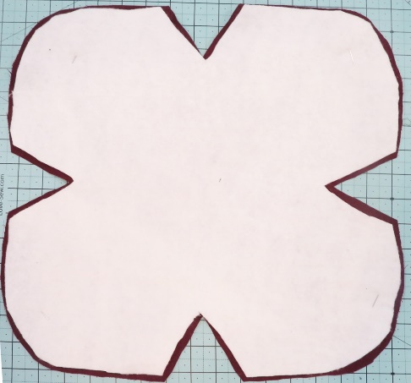
2) To shape the fabric and batting pieces, first fold them in fourths. Following the Cutting Diagram on p. 1, cut darts and a curve. (If you have a template made, it's easy to lay it down, lined up with the folded edges, then clip off the 3 corners.)
Photo 2: A fabric layer topped by trimmed batting layer. (The 4 V cuts are darts.)

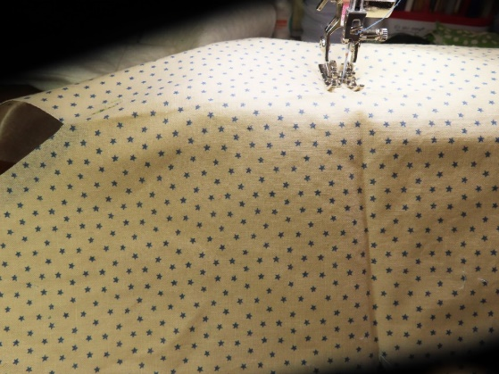
- Press the fold lines of the fabric pieces! Pin a batting piece to the back of a fabric piece. Trim off 1/8"-1/4"of the batting edge to remove bulk (as in Photo 2 above) Flip to the fabric side; sew a seam along each fold. (This quilts the pieces together. See photo 3.)
Photo 3: Quilting an X along folds from dart to dart
through 2 layers, one fabric and one cotton
batting.

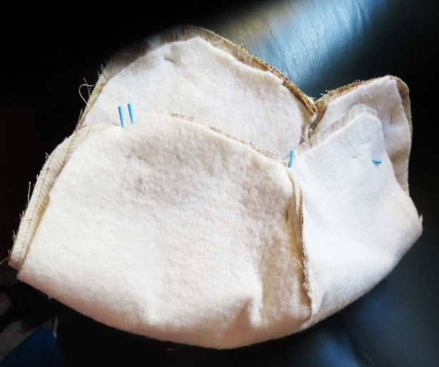
- Next, fold the darts, which are the V cuts (with fabric right side to right side and batting on the outside) and sew the 4 darts with 3/8" seams. Repeat with 2nd fabric and batting. (Notice the little dart seam in Photo 4.)

Photo 4: Bowl cozy 2-layer pieces pinned together,
all the way around, matching 4 darts to 4 darts.
Leave open about 4" for turning, here between the
two pins and next pin to the right.

https://sewgocreate.com
- Pin together the two batting-backed fabric pieces right side to right side. Sew with a 3/8" seam most of the way around, leaving 3-4" open (as in Photo 4 on p. 2). Turn right-side out. (I then usually press around the edge.)
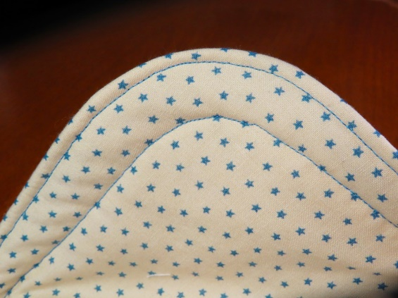

- While it's optional, I use an edge-stitch foot and stitch around the edge. I then stitch again about 3/4" from the first edgestitch (as shown in Photo 5.)
Photo 5: Two rows of optional edgestitching.

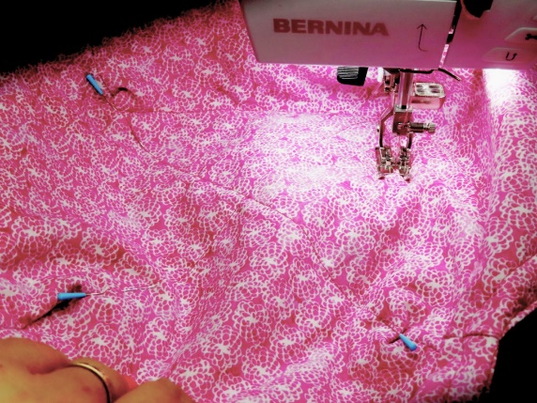
- Finish by sewing a square inside, round the crisscrossed quilting seams. It's hard to explain, but what I do is pin together the top and bottom fabric pieces together about 1/2" below each dart, being sure that the pin picks up the quilting stitching on the fold on top AND on bottom. Then I sew diagonally from pin to pin, making a square. See Photo 6. (This provides more quilting through all layers and holds the bowl shape in place better. The pins help keep the stitching accurate on bottom as well as top.)
Photo 6: Quilting an interior square from end of
each dart through all layers.

Done. No hand-stitching at all. And you've used up a couple of orphan fat
quarters or some leftover fabric. I always have leftover batting, too. I don't know
who first came up with this idea, so I can't really give credit where it's due.
I just know that this is MY method! You can make smaller ones, too, for soup
bowls--just decrease the size of the original squares!

https://sewgocreate.com
© 2023 by Libby J. Christensen, Christensen Creations ALL RIGHTS RESERVED
Every effort has been made to ensure that the contents of this pattern are accurate. However, Christensen Creations cannot be responsible for printing errors, variations in sewing equipment, or differences in individual workmanship. This pattern is protected by copyright and may not be transferred in any form without the consent of Libby J. Christensen.

